

A report on

**“MULTISPECTRAL SATELLITE IMAGE DEHAZING”**

**Submitted in partial fulfilment for the award of the degree of**

**BACHELOR OF TECHNOLOGY IN**

**COMPUTER SCIENCE & ENGINEERING (DATA SCIENCE)**

Submitted by

**G Sai Avinash**

**19BTRCR048**

**Shaistha M**

**19BTRCR014**

**Naga Kushal Ageeru**

**19BTRCR047**

**Nishen Ganegoda**

**19BTRCR061**

**…**

**Under the guidance of**

**Dr.M.John Basha**

**Assistant Professor**

**Faculty of Engineering & Technology Jain (Deemed-To-Be University)**

**Department of Computer Science & Engineering** Jain Global Campus, Kanakapura Taluk - 562112 Ramanagara District,

Karnataka, India

**2022-2023**



### DEPARTMENT OF COMPUTER SCIENCE & ENGINEERING

Jain global campus, Kanakapura taluk Ramanagara District – 562112 Karnataka, India.

### CERTIFICATE

This is to certify that the project work titled **“MULTISPECTRAL SATELLITE IMAGE DEHAZING”** is carried out by **G Sai Avinash (19BTRCR048), Shaistha M (19BTRCR014), Naga Kushal Ageeru (19BTRCR047), Nishen Ganegoda (19BTRCR061)** a bonafide students of Bachelor of Technology at the Faculty of Engineering & Technology, Jain (Deemed- to-be University), Bangalore in partial fulfilment for the award of degree Bachelor of Technology in Computer Science & Systems Engineering (Internet of Things), during the Academic year **2022- 2023**.

|  |  |  |
| --- | --- | --- |
| **Guide Name** | **Program Head Name** |  |
| Dr.M.John Basha | Head Designation |  |
| Dept. of CSE | Dept. of CSE |  |
| Faculty of Engineering &Technology | Faculty of Engineering &Technology |  |
| Jain Deemed to be University | Jain Deemed to be University |  |
| Date: 12-12-22 | Date: |  |

Name of the Examiner Signature:

1:

2:

# DECLARATION

We, **G Sai Avinash (19BTRCR048), Shaistha M (19BTRCR014), Naga Kushal Ageeru (19BTRCR047), Nishen Ganegoda (19BTRCR061)** are students of eighth semester **B. Tech in Computer Science & Engineering (Data Science)**, at Faculty of Engineering & Technology, Jain (Deemed- To-Be University), hereby declare that the project work titled **“MULTISPECTRAL SATELLITE IMAGE DEHAZING”** has been carried out by us and submitted in partial fulfillment for the award of degree in **Bachelor of Technology in Computer Science & Engineering (Data Science)** during the academic year **2022-2023.**

Signature

**G Sai Avinash**

USN:19BTRCR048

**Shaistha M**

USN: 19BTRCR014

**Naga Kushal Ageeru**

USN: 19BTRCR047

**Nishen Ganegoda**

USN: 19BTRCR061

Place: Bangalore

Date:

# ACKNOWLEDGEMENT

*It is a great pleasure for us to acknowledge the assistance and support of a large number of individuals who have been responsible for the successful completion of this project work.*

*First, we take this opportunity to express our sincere gratitude to* ***Faculty of Engineering & Technology, Jain (Deemed-to-be University),*** *for providing us with a great opportunity to pursue our Bachelor’s Degree in this institution.*

*In particular we would like to thank* ***Dr. Hariprasad S A, Director, Faculty of Engineering & Technology, Jain (Deemed-to-be University),*** *for his constant encouragement and expert advice.*

*We place on record, our sincere thank you to* ***Dr.Geetha, Dean,******Faculty of Engineering & Technology****,* ***Jain (Deemed-to-be University),*** *for the continuous encouragement.*

*It is a matter of immense pleasure to express our sincere thanks to* ***Dr. S.Ramesh*** ***Program******Head*** *,* ***Computer Science & Engineering****,* ***Jain (Deemed- to-be University),*** *for providing right academic guidance that made our task possible.*

*It is a matter of immense pleasure to express our sincere thanks to* ***Prof. Mohamed Zabeeulla, , Assistant Professor, Dept. of Computer Science & Engineering, Jain (Deemed- to-be University),*** *for providing right academic guidance that made our task possible.*

*We would like to thank our Project Coordinator* ***Dr.M.John Basha, , Assistant Professor, Dept. of Computer Science & Engineering, Jain (Deemed- to-be University),*** *for providing right academic guidance that made our task possible.*

*We would like to thank our guide* ***Guide Name Assistant Professor****,* ***Dept. of Computer Science & Engineering****,* ***Jain (Deemed-to-be University),*** *for sparing his valuable time to extend help in every step of our project work, which paved the way for smooth progress and fruitful culmination of the project.*

*We would like to thank all the staff members of* ***Dept. of Computer Science & Engineering, Jain (Deemed-to-be University)****, for their support.*

*We are also grateful to our family and friends who provided us with every requirement throughout the course.*

*We would like to thank one and all who directly or indirectly helped us in completing the Project work successfully.*

*Signature of Students*

### Table of Contents

Certificate ii

Declaration iii

Acknowledgment iv

Table of Content v

Abstract vii

List of Figures viii

Chapter 1

1. INTRODUCTION 1
   1. Overview 2
   2. Problem Definition 3
   3. Objective 3
   4. Methodology 4
   5. Hardware and software tools used 4

Chapter 2

1. LITERATURE SURVEY 6
   1. Related work 7
   2. Existing System 8
   3. Limitations of existing system 9
   4. Proposed System 10
   5. Advantages of Proposed System………………………………………………………………………………10

Chapter 3

1. SYSTEM DESIGN 11
   1. Architecture 11
   2. Sequence Diagram 12

Chapter 4

1. TOOL DESCRIPTION 13
   1. Hardware Requirements 13
   2. Software Requirements 14

Chapter 5

1. IMPLEMENTATION (Optional) 15

Conclusion And Future Scope 22

References 23

Appendix-I 24

### ABSTRACT

In this paper, we propose a simple but effective image prior - dark channel prior to remove haze from satellite images. The dark channel prior is a kind of statistics of the haze-free images. It is based on a key observation - most local patches in haze-free satellite images contain some pixels which have very low intensities in at least one-color channel. Using this prior with the haze imaging model, we can directly estimate the thickness of the haze and recover a high-quality haze-free image. Results on a variety of satellite haze images demonstrate the power of the proposed prior. Moreover, a high-quality depth map can also be obtained as a by-product of haze removal.

### List of Figures

|  |  |  |
| --- | --- | --- |
| Fig No. | Description of the figure | Page No. |
| 3.1 | Circuit Diagram | 11 |
| 3.2 | Sequence Diagram | 12 |
| 5.1 | An abstracted view of the implementation for the wheelchair movement | 15 |
| 6.1 | Hold | 18 |
| 6.2 | Moving Backward | 18 |
| 6.3 | Moving Forward | 19 |
| 6.4 | Turning Left | 19 |
| 6.5 | Turning Right | 20 |
| 6.6 | Points projected on hand | 20 |

**Chapter 1**

**Introduction**

#### Overview

#### In recent years there has been a growing interest in using satellite imagery for different tasks in modeling the earth, e.g., creating accurate maps. For this to be possible the satellite images must have a high enough resolution to be able to detect small details.

#### The usability of the images does not only depend on their resolution but heavily on the quality of their content as well.

#### One great disadvantage when taking images from outside of the atmosphere is that the result will be distorted since the light is forced to pass through particles in the atmosphere which will scatter and absorb the light.

#### The distortion will reduce the applicability of the resulting images if they are not corrected. Since these effects are inevitable in the field of remote sensing it is important to have effective methods to remove them.

#### A multispectral image dehazing tries to improve interpretability in the image regions affected by the presence of haze during acquisition. In remote sensing, optical multispectral satellite images often suffer from the presence of haze resulting in a lack of contrast and data interpretation.

#### The process of dehazing tries to recover the information affected due to the presence of haze and therefore servers to increase the data interpretation for manual or automated operations. Haze detection and removal is a challenging and important task for optical multispectral data correction.

#### Problem Definition

#### Objective

#### Images captured in hazy or foggy weather conditions make the object features difﬁcult to identify by human vision.

#### The main objective is to improve the visual quality and read the information behind the hazed image. It is achieved using DCP algorithm on the dataset.

#### General Applications

#### Remote Sensing

#### Weather Forecasting

#### Pollution Estimation, etc.

#### Methodology

#### DARK CHANNEL PRIOR (DCP)

#### Effective image prior-dark channel prior to remove haze from a single input image.

#### The dark channel prior is a kind of statistics of outdoor haze-free images.

#### It is based on a key observation – most local patches in outdoor haze-free images contain some pixels whose intensity is very low in at least one color channel.

#### A widely used haze imaging formation model is present as:

#### I(x) = J(x)t((x) + A(1 -t(x))

#### J(x) haze free image, A : atmospheric light,

#### 1(x) : transmission t(x) = e-Bg(x)

#### 

#### Hardware and Software used

#### System requirements:

#### Operating system: WINDOWS/LINUX/MAC

#### RAM: 4-8GB

#### 80 GB HDD

#### GPU:4GB(NVIDIA/AMD)

#### Software Requirements:

#### Anaconda

#### Python version 3 and above version

#### Jupyter Notebook

#### Python libraries (Numpy, pandas, sklearn, scipy

### Chapter 2

**Literature Survey**

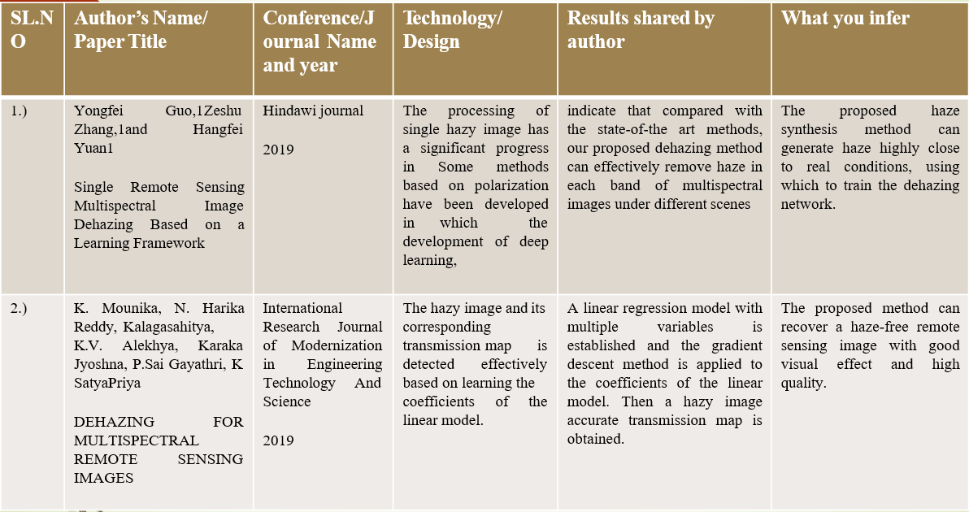

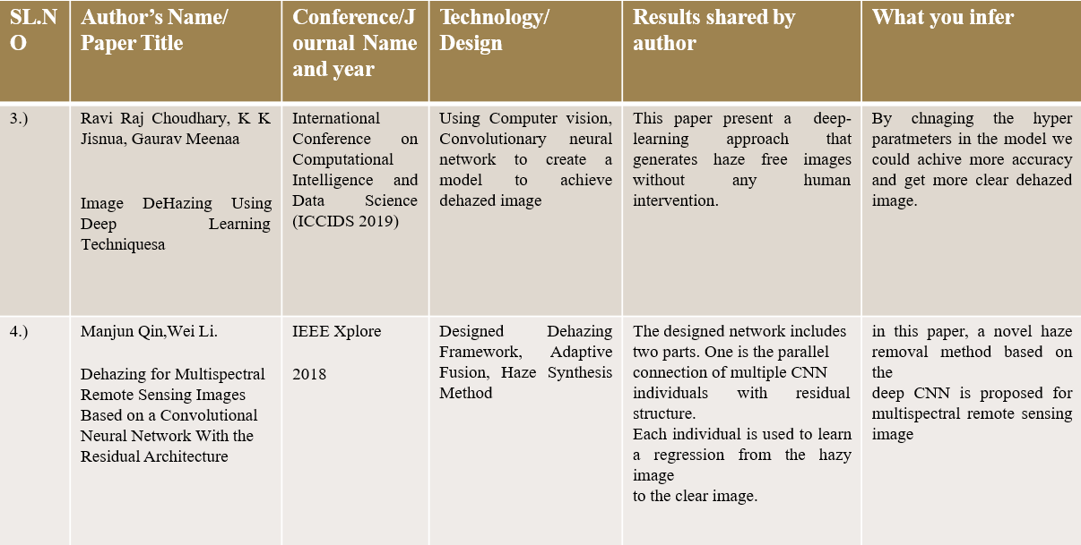

## Related Work

#### Existing Work

#### Limitations in Existing System

The DCP is proposed by He et al, which is a kind of statistics of extensive haze-free outdoor images, that is within most local patches (except for the sky region), at least one-color channel contains the pixel whose intensity is extremely low and tends to be zero, and it can be expressed as: where is the RGB color channel index, is a local patch centered at and are the color channel and dark channel that correspond to image, respectively.

This prior, combined with the atmospheric scattering model, enables us to directly estimate the rough transmission for a hazy image. Despite the effectiveness of this prior, the image restored via DCP is prone to suffer from the over-enhanced sky region, as well as the poor global edge-consistency. Generally, the reason can be explained as follows:

DCP fails for the region where the scene brightness is similar to the atmospheric light (such as the sky region), since the dark channel that corresponds to the sky region is obviously higher than zero, and therefore, the transmission will be inevitably over-estimated if we apply the DCP directly.

DCP is a patch-based procedure; thus, the transmission map that is estimated via DCP may suffer from the poor edge-consistency property, and this problem will further lead to negative visual effects in the corresponding restored image.

#### Proposed System

### Chapter 3

**System Design**

#### Architecture

The segments are based on sky and non-sky regions.

Dark channel and atmospheric light are computed for each segment. Transmission map is estimated on the basis of average value of atmospheric light. The refinement

process is same as discussed in previous methodology, that is, based on guided image filter. Segmentation-based algorithm is efficient in terms of removing fog particles, yield high SSIM and PSNR, and lower value of MSE.

In this approach, a semi-automatic segmentation is used to convert foggy image into sky and non-sky segments. Foreground and background pixels are selected manually to convert image into two segments. Scribbles are drawn onto the image, which divides then image into background and foreground pixels and then graph theory is applied for fast segmentation. After converting foggy image into sky and non-sky segment, dark channel is computed for each segment using Eq. A minimum filter of window size ω is applied to compute dark channel, where ω is kept at 31 × 31 for optimized results.

After successfully computing dark channels, atmospheric light is estimated using each dark channel. Final atmospheric light is computed using the average values of

each atmospheric light. Transmission map estimation and refinement is done using the same procedure as discussed in first proposed methodology. The resultant transmission map along with refined transmission map computed using the average value of atmospheric light. After refining the transmission map, defogged image is reconstructed. Fog-free image is reconstructed.

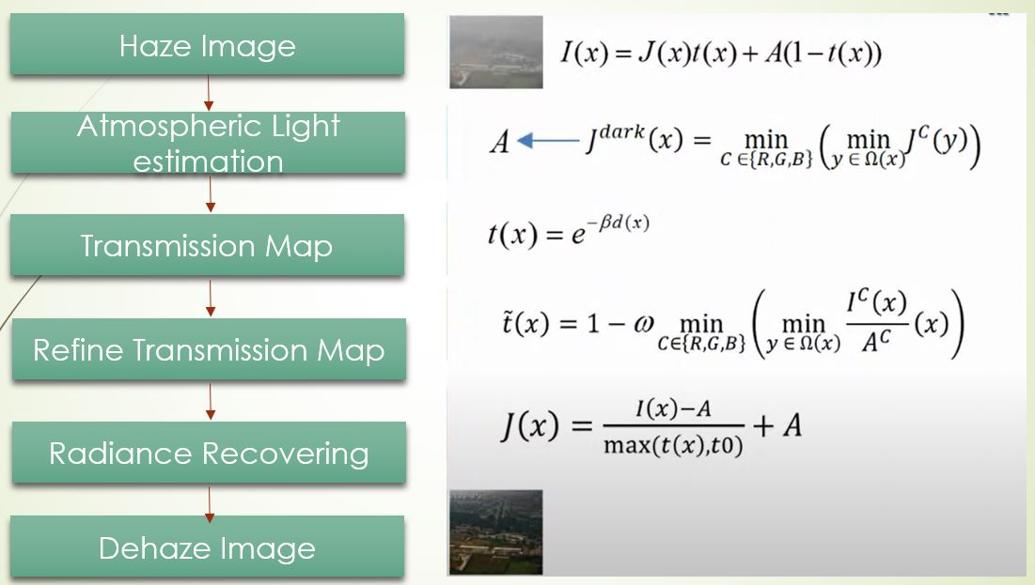

*Figure 3.1 Circuit Diagram*

#### Sequence Diagram

In this approach, a semi-automatic segmentation is used to convert foggy image into sky and non-sky segments. Foreground and background pixels are selected manually to convert image into two segments. Scribbles are drawn onto the image, which divides the image into background and foreground pixels and then graph theory is applied for fast segmentation.

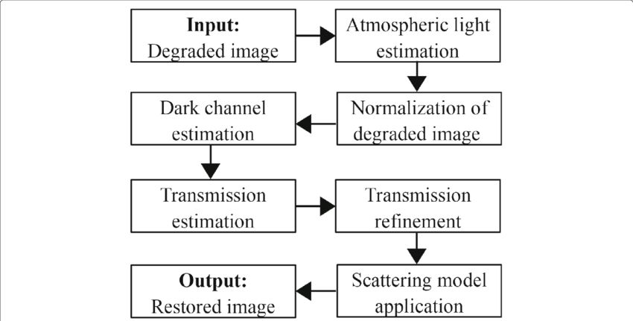

*Figure 3.2 Sequence Diagram*

### Chapter 4

**Tool Description**

#### 4.1 Hardware Requirements: Description

##### Operating System:

An operating system (OS) is the program that, after being initially loaded into the computer by a boot program, manages all of the other application programs in a computer. It includes:

* Windows
* Mac
* Linux, etc.

##### Random Access Memory:

It is a hardware device generally located on the motherboard of a computer and acts as an internal memory of the CPU. It allows CPU store data, program and program results when you switch on the computer. Its is the read and write memory of a computer, which means the information can be written to it as well as read from it.

* 8GB -16GB RAM

##### Hard Disk Drive:

A hard disk drive (sometimes abbreviate as a hard driver ,HD or HDD) is a non-volatile data storage device. It is usually installed internally in a computer, attached directly to the disk controller of the computer's [motherboard](https://www.computerhope.com/jargon/m/mothboar.htm). It contains one or more [platters](https://www.computerhope.com/jargon/p/platter.htm), housed inside of an air-sealed casing. Data is written to the platters using a magnetic head, which moves rapidly over them as they spin.

* 80 GB or more

#### 4.2 Software Requirements: Description

##### Python:

Python is an interpreted, object-oriented, high-level programming language with dynamic semantics. Its high-level built in data structures, combined with dynamic typing and dynamic binding, make it very attractive for Rapid Application Development, as well as for use as a scripting or glue languages to connect existing components together.

* Version 3 or above

##### Jupyter Notebook:

Jupyter notebook is application for creating and sharing computational documents. It is used mainly in the fields of data to write, share and run the code. It provides units called cells for writing the code.

##### Python Libraries:

Python has libraries to perform various tasks and functions. It includes NumPy and SciPy for components, Pandas from data frames, tensorflow for deep learning , etc.

* NumPy
* Pandas
* SciKit-Learn
* Tensorflow

### Chapter 5

**Implementation (optional)**

Code:

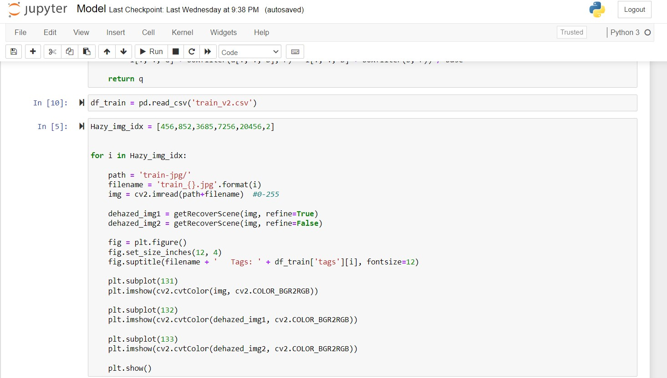



Output:

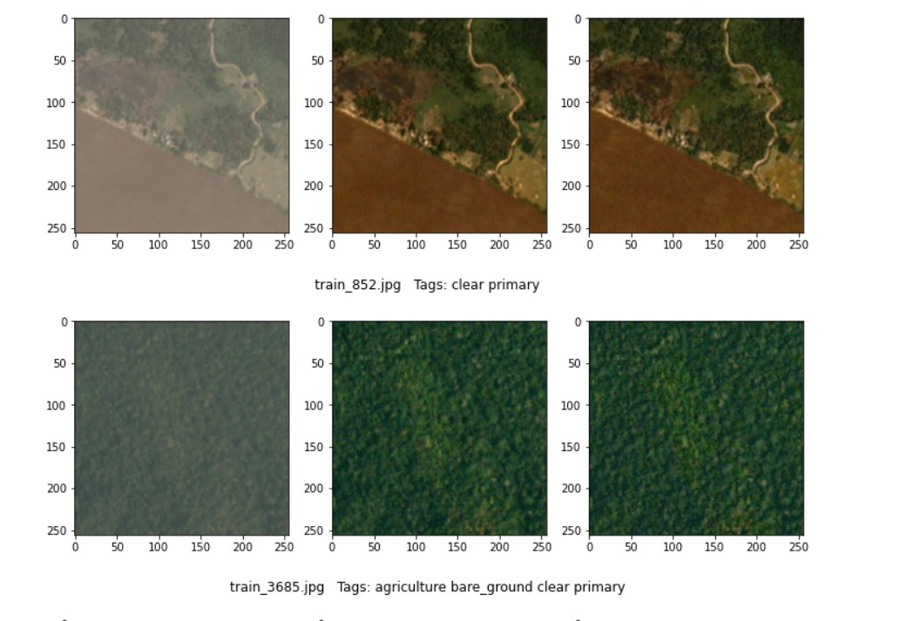

## Conclusion and Future Scope

This vision-based technology overrules the touch technology as it is less expensive and can be used for great future in HCI based systems. It can be widely used in the fields of robotics, biomedical instrumentation, computer gaming.It can be used for various number of applications such as volume control, swipe gestures, scroll up-down, zoom in, zoom out.To convert any traditional PC/Laptop/Mobile into a touch screen device.This application provides a vital aid to patients who don’t have control over their limbs. The last and the foremost application of the system is that it can be used as Virtual Teaching especially for professors or lecturers who are color blind with impaired vision or lecturers with vertebral deformities, impaired legs and spinal abnormalities. They can just make gestures in air which will be tracked and produced on the laptop screen and the output will be projected on a wall for students present in the class.

## References

[1.] Liu J, Wang S, Wang X, Ju M, Zhang D. A Review of Remote Sensing Image Dehazing. Sensors (Basel). 2021 Jun 7;21(11):3926. doi: 10.3390/s21113926. PMID: 34200320; PMCID: PMC8201244.

[2.] Z. He, C. Gong, Y. Hu and L. Li, "Remote Sensing Image Dehazing Based on an Attention Convolutional Neural Network," in *IEEE Access*, vol. 10, pp.

68731-68739, 2022, doi: 10.1109/ACCESS.2022.3185627.

[3.] Hindawi. “Single Remote Sensing Multispectral Image Dehazing Based on a Learning Framework.” Single Remote Sensing Multispectral Image Dehazing Based on a Learning Framework

### Appendix – I

|  |  |  |  |  |
| --- | --- | --- | --- | --- |
| STUDENT NAME | EMAIL ID | PERMANENT  ADDRESS | PHONE  NUMBER | PHOTOGRAPH |
|  |  |  |  |  |
|  |  |  |  |  |
|  |  |  |  |  |
|  |  |  |  |  |